**Analytical methods**

**Major element analyses of magnetite by EPMA**

The mineral compositions of the studied rocks were analyzed using an electron microprobe analyser (EPMA; JXA-8100, JEOL) with a 15 kV accelerating voltage, 20nA probe current, and 5 μm beam diameter at the Key Laboratory of Deep Earth Dynamics, Ministry of Natural Resources, Institute of Geology, Chinese Academy of Geological Science (Beijing). Natural and synthetic minerals of SPI Company were used for standardization, and ZAF corrections were carried out.

**Trace element analyses of magnetite by LA-ICP-MS**

Major and trace element analyses were conducted by LA-ICP-MS at the State Key Laboratory of Ore Deposit Geochemistry, Institute of Geochemistry Chinese Academy of Sciences. Laser sampling was performed using the NWR UP-213 Nd:YAG laser. An Agilent 7700x ICP-MS instrument was used to acquire ion-signal intensities. Helium was applied as a carrier gas which was mixed with Argon via a T-connector before entering the ICP-MS. Each analysis incorporated a background acquisition of approximately 30 s (gas blank) followed by 50 s of data acquisition from the sample. Using a range of beam sizes from 40 to 60 μm, depending on grain size. Element contents were calibrated against multiple-reference materials (GSE-1G, BCR-2G, BIR-1G and BHVO-2G) combined with internal standardization (Dare et al., 2012). The secondary standard is BC-28 and GOR128-g. Fe was used as the internal standard. The preferred values of element concentrations for the USGS reference glasses are from the GeoReM database (http://georem.mp ch-mainz.gwdg.de/). Off-line selection and integration of background and analyte signals, and time-drift correction and quantitative calibration were performed by ICPMSDataCal (Liu et al., 2008a; Liu et al., 2010a).



Figure S1. Magnetite trace element concentrations in different deposit types (without removing outliers). Height of the colored boxes represents the interquartile range (IQR). Horizontal black lines inside the box represent the median value, and white dots represent the mean value. The whiskers extending up and down outside the box represent the area of 1.5IQR (IQR = Q3–Q1, Q1: first quartile, Q3: third quartile). Black dots represent the outliers deviating by more than ±1.5*IQR but not more than ±3*IQR.

Figure S2. Confusion matrices of the testing set (Without removing outliers).



Table S10. Classification Report for the RF and SVM classifiers (Without removing outliers).

|  |  |  |  |  |  |  |  |  |
| --- | --- | --- | --- | --- | --- | --- | --- | --- |
| Method\Forecast type | BIF | IOA | IOCG | Magmatic | Porphyry | Orogenic | Skarn | Volcanic |
| *Chuquicamata Cu-Mo deposit* (A total of 135 magnetite data) | | | | | | | | |
| RF |  | 7 | 6 |  | 122 |  |  |  |
| SVM |  | 2 |  |  | 131 |  | 2 |  |
| *Kalatongke Cu–Ni sulfide deposit* (A total of 246 magnetite data) | | | | | | | | |
| RF |  | 34 |  | 181 | 6 |  |  | 25 |
| SVM |  | 47 |  | 101 | 4 |  | 94 |  |
| *Makeng Fe deposit* (A total of 78 magnetite data) | | | | | | | | |
| RF | 2 |  |  |  |  |  | 73 | 3 |
| SVM | 2 |  |  |  |  |  | 72 | 4 |
| *Luoyang Fe deposit* (A total of 59 magnetite data) | | | | | | | | |
| RF |  |  |  |  |  |  | 57 | 2 |
| SVM |  |  | 4 |  | 2 |  | 51 | 2 |

Table S11. All hyperparameters in the models and the optimal values.

|  |  |  |
| --- | --- | --- |
| method | parameter | value |
| RF | n_estimators | 130 |
| max_depth | 18 |
| bootstrap | True |
| min_samples_leaf | 1 |
| min_samples_split | 2 |
| SVM | kernel | RBF |
| C | 10 |
| gamma | 1 |
| MLP | activation | tanh |
| solver | adam |
| alpha (regularization term) | 0.01 |
| hidden_layer_sizes | (50,50,20) |
| max_iter | 1000 |

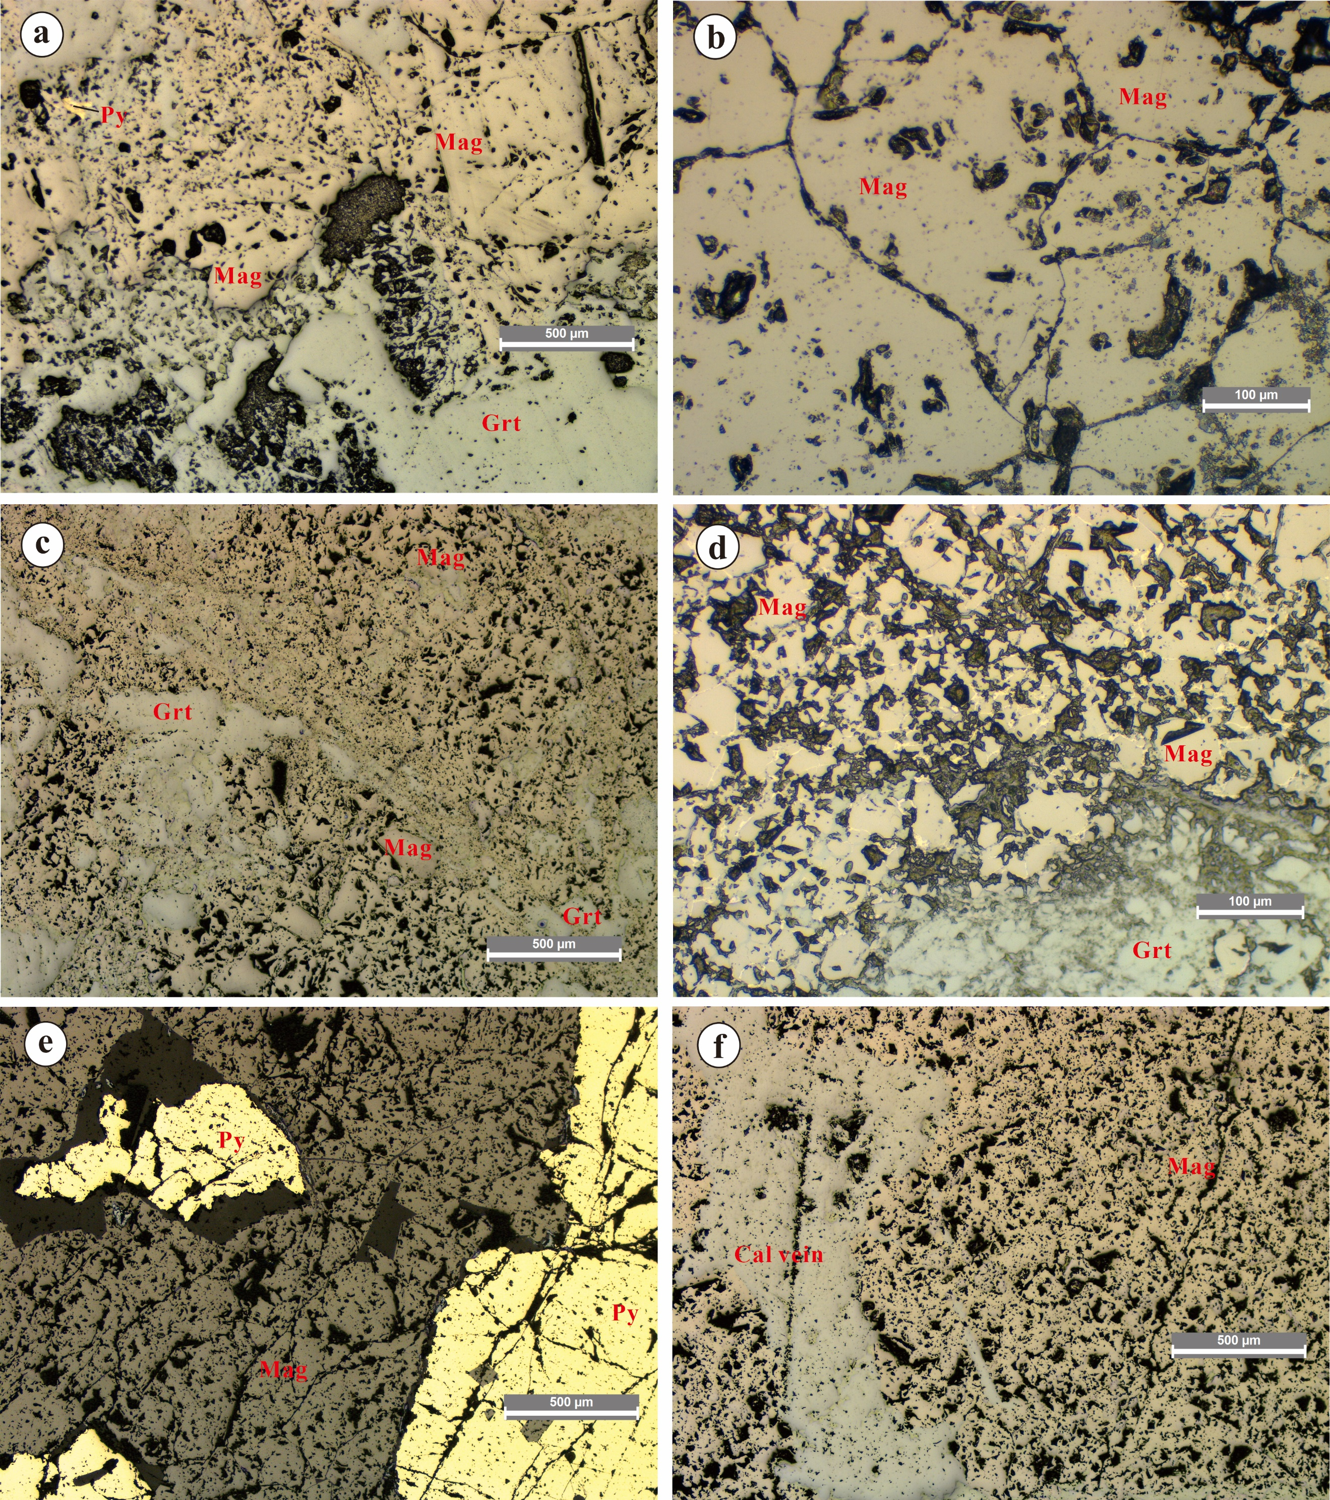

Figure S3. Electron microscope photos of magnetite from the Makeng and Luoyang deposits. a Sample from the Luoyang deposit (LY-2-1) consisting of pyrite, magnetite and garnet. b Massive magnetite from the Makeng deposit (O-37-g). c Massive magnetite from the Makeng deposit (O-38-g), with brown-red garnet veins interspersed. d Dense disseminated magnetite from the Makeng deposit (O-26-g), with visible disseminated tan-grey-green garnet. e Sample from the Luoyang deposit (LY-1-11) consisting of pyrite and magnetite. f Massive magnetite from the Makeng deposit (O-19-g), with visible calcite veins. Mag: magnetite, Py: pyrite, Grt: garnet, Qtz: quartz, Cal: calcite.